Project Report On

**Speech Therapy Assessment Application**

Submitted By

Chirag Chawade 22010070

Harsh Chawla 22010826

Niraj Amrutkar 22010910

Suniket Khairnar 22010917

Under the Guidance of

Prof. Aparna Junnarkar

*In Partial fulfilment of*

Bachelor of Technology in Information Technology [2023-2024]

At



Department of Information Technology

Vishwakarma Institute of Information Technology, Pune 411048

*Affiliated To*



Savitribai Phule Pune University, Pune

Bansilal Ramnath Agarwal Charitable Trust’s

**Vishwakarma Institute of Information Technology, Pune**

**https://lh7-us.googleusercontent.com/qgooM3QwfhOVC3ddnQlZtOSEDOVIAcRoScEDGBl58jYBsAC0zY5Rq6SVydSbjYEs62zsa8X7QANQzIksdoXyp4VoXx01aF1Wkor_g4Po6549fjSfBB32NTOG5tmeJnRimeL1Oljztkt7WCJ93jCnDdlx1XQQxJatKgIqiMavOQzmiCOuqHiu3Aox5suKnw**

**CERTIFICATE**

This is to certify that the work entitled **“Speech Therapy Assessment Application"** is a bonafide work carried out by Mr. Niraj Amrutkar, Mr. Suniket Khairnar, Mr. Harsh Chawla, Mr. Chirag Chawade in partial fulfilment of the award of Bachelor of Technology in Information Technology, Savitribai Phule Pune University, Pune, during the year 2024. The project report has been approved as it satisfies the academic requirements in respect of the project work prescribed for the Bachelor of Technology Degree.

Prof. Aparna Junnarkar

**Project Guide**

Prof. Pravin Futane Dr. Vivek Deshpande

**Head, IT Department Director, VIIT PUNE.**

Date:

Examiner: 1 ……………. 2. …………….

Place: Pune

# Plagiarism Report

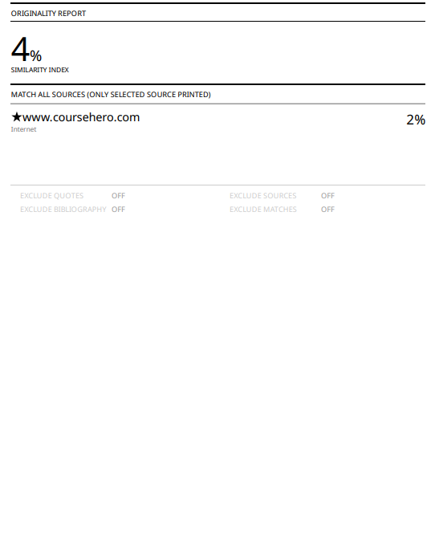

**Acknowledgement**

We would like to express our sincere gratitude to Professor Pravin Futane, Head of the Department, for his exemplary leadership and invaluable guidance throughout the duration of this project. His unwavering support and provision of essential resources were instrumental in the successful completion of this project report.

Our heartfelt appreciation extends to Professor Aparna Junnarkar, our esteemed project guide, for her mentorship, insightful feedback, and constant encouragement. Her expertise and dedication significantly contributed to the quality and depth of our work.

We extend our thanks to all the faculty members of the Department of Information Technology at VIIT, Pune. Their valuable time, support, constructive comments, suggestions, and motivation played a pivotal role in shaping this project.

Special gratitude is extended to Mrs. Aparna Junnarkar, Dr. Jayashri Bagade, Mrs Wankhede, and the entire institute for providing the necessary infrastructure, internet access, and library facilities. Their contributions have been essential in facilitating our research and project development.

We acknowledge and appreciate the collaborative environment fostered by the Department and the institute, which has been conducive to our academic and project endeavours.

Chirag Chawade 22010070

Harsh Chawla 22010826

Niraj Amrutkar 22010910

Suniket Khairnar 22010917

ABSTRACT

This report outlines the development of a mobile application aimed at addressing the speech therapy needs of children diagnosed with Autism Spectrum Disorder (ASD). ASD is a complex developmental condition characterized by communication challenges. Children with ASD often struggle with speech and language development, making early intervention crucial. The mobile application serves as a vital tool to assist these children in improving their communication skills. The motivation behind this project stems from the pressing need to provide effective and accessible solutions for children with ASD. Traditional speech therapy methods often require extensive in-person sessions, which can be both logistically challenging and costly for families. Moreover, the variability in ASD symptoms demands personalized interventions. By leveraging technology and creating a user-friendly mobile app, the project aims to bridge these gaps, offering a cost-effective and customizable solution that empowers parents and caregivers to actively participate in the child's therapy journey. The mobile application employs modern technologies, with a focus on Android development and utilization of articulatory phonetics in the Marathi language. The app features two core modules: an administrative section for customization and a user-friendly interface for children and their parents. The admin module allows for the addition, modification, or deletion of speech therapy content, including words, audio files, and assessment questions in Marathi. The user module offers children the opportunity to engage with speech therapy exercises in a gamified manner, listen to audio pronunciations, and undergo assessments to monitor progress. By combining technology, linguistic expertise, and a user-cantered design, the project aims to provide an innovative and effective tool for addressing the unique speech therapy needs of children with ASD. Keywords: ASD, autism, app development, react-native, speech therapy Problem Statement: The integration of technology and specialized therapeutic methodologies into a cohesive, user-friendly mobile application, ensuring equitable access to high-quality autism intervention regardless of geographical or socioeconomic barriers

Table of Contents

Plagiarism Report 3

1 INTRODUCTION: 9

1.1 Motivation 9

1.2 Need of Proposed System 9

1.3 Brief Introduction to Application 9

1.4 Reason Behind Making the Application 10

1.5 How Proposed System Will Help Users 10

2 LITERATURE SURVEY 12

2.1 Survey 12

2.2 Literature Review 14

2.3 Review of Existing System 15

3 SYSTEM REQUIREMENT SPECIFICATION 16

3.1 Product Perspective 16

3.2 Product Functions 16

3.3 User Classes and Characteristics 16

3.4 Operating Environment 17

*3.4.1* Hardware Requirements: 17

*3.4.2* Software Requirements: 17

4 MODULES SPLIT-UP 18

4.1 Database: 18

5 USER DOCUMENTATION EXTERNAL INTERFACE REQUIREMENTS 20

5.1 Wireframes: 20

5.2 User Interfaces 22

5.2.1 Doctor Screens: 22

5.2.2 Patient Screens: 27

5.3 Hardware Interfaces 32

5.4 Software Interfaces 33

6 SYSTEM FEATURES 35

7 OTHER NONFUNCTIONAL REQUIREMENTS 37

7.1 Performance Requirements 37

7.2 Security Requirements 37

7.3 Software Quality Attributes 37

7.4 Business Rules 37

8 PROJECT ANALYSIS AND DESIGN 38

8.1 Use case Diagram 38

8.2 Admin Flow Diagram 39

8.3 User Flow Diagram 40

8.4 Sequence Diagram 41

8.5 Class Diagram 42

8.6 Component Diagram 43

8.7 Deployment Diagram 44

8.8 ER Diagram: 45

9 TEST CASES 46

10 CONCLUSION 49

10.1 Main Findings: 49

10.2 Significance of the Research: 49

10.3 Areas for Future Research: 49

11 PROJECT PLAN 2.0 50

12 REFERENCES 51

List of Figures

Figure 5.1 Login/Sign Up Pages 20

Figure 5.2 Patient Screens 21

Figure 5.3 Doctor Screens 22

Figure 5.2.1.1 Login Screen………………………………………………………………………………………………………………23

Figure 5.2.1.2 Dashboard and Patient List………………………………………………………………………………………..24

Figure 5.2.1.3 Patient Profile and Assign Cards…………………………………………………………………………………25

Figure 5.2.1.4 Progress of Patient…………………………………………………………………………………………………….26

Figure 5.2.1.5 Create Card……………………………………………………………………………………………………………….27

Figure 5.2.2.1 Patient Login/ Register window…………………………………………………………………………………28

Figure 5.2.2.2 Forget Password………………………………………………………………………………………………………..29

Figure 5.2.2.3 Reset Password…………………………………………………………………………………………………………30

Figure 5.2.2.4 Assessment……………………………………………………………………………………………………………….31

Figure 5.2.2.5 Give Assessment and get score………………………………………………………………………………….32

Figure 8.1 Use Case Diagram 38

Figure 8.2 Admin Flow Diagram 39

Figure 8.3 User Flow Diagram 40

Figure 8.4 Sequence Diagram 41

Figure 8.5 Class Diagram 42

Figure 8.6 Component Diagram 43

Figure 8.7 Deployment Diagram 44

Figure 8.8 ER Diagram 45

List of Tables

Table 1 Survey Table…………………………………………………………………………………..11

Table 2: Comparison table of various applications and proposed application………………………...13

Table 3: Test Cases…………………………………………………………………………………….43

# INTRODUCTION:

## Motivation

The primary motivation driving this project is the pressing need to address the speech and language development challenges faced by children diagnosed with Autism Spectrum Disorder (ASD). ASD is a complex developmental condition that often manifests in communication difficulties, making early intervention essential. Traditional methods of speech therapy are often constrained by geographic limitations and cost, hindering access to critical therapy services for many families. To bridge this gap, the project embarked on the development of a mobile application tailored to the unique needs of children with ASD, offering a convenient, cost-effective, and accessible solution.

## Need of Proposed System

The need for the proposed system can be outlined as follows:

1. Lack of concrete treatment on Autism: Autism is not defined by any clear symptoms; hence it lacks any concrete treatment. The treatment is thus varied depending upon the symptoms.
2. Use of technology: Despite the thriving technology sector, its integration into the medical industry for Autism treatment has been limited. However, the incorporation of React-Native, SQL, Cloudinary, and Power BI into the project leverages cutting-edge technology to address this gap and provide innovative solutions for Autism treatment.
3. Elimination of unnecessary follow ups: With the treatment available at one click on the mobile application.

## Brief Introduction to Application

The developed application functions as a dual-purpose system, comprising an administrative module and a user module. It provides essential support to children with ASD and enables healthcare professionals to effectively monitor their progress. In terms of functionality, the application is designed to establish communication with a database for the secure storage of user data. The administrative module grants authorized users the ability to manage therapy content, which includes tasks such as adding, modifying, or deleting speech therapy materials and assessment questions specifically tailored to the Marathi language. Conversely, the user module offers children and their parents a user-friendly interface for participating in speech therapy exercises, listening to audio pronunciations, and undergoing assessments to track their progress.

## Reason Behind Making the Application

1. Aid Children with ASD: Develop the app to assist children with Autism Spectrum Disorder (ASD), specifically targeting speech and language challenges.
2. Empower Parents/Caregivers: Enable parents and caregivers to actively participate in therapy, reducing the need for frequent medical visits.
3. Utilize Modern Technology: Leverage Android and technology advancements to make therapy accessible and effective.
4. Streamline Administration: Simplify administrative tasks for healthcare professionals, allowing them to focus on patient care.
5. Customize Therapy: Tailor therapy materials to each child's specific needs, recognizing the variability in ASD symptoms.
6. Address Contemporary Needs: Respond to the growing demand for innovative medical solutions, especially in the context of ASD therapy.

## How Proposed System Will Help Users

The proposed system will offer several significant benefits to its users, including:

* Enhanced Communication Skills: Children with ASD will have access to a structured and engaging platform for speech therapy.
* Convenience and Accessibility: Parents and caregivers will find the system convenient, as they can actively engage in therapy sessions with their children without the need for frequent visits to healthcare facilities.
* Personalized Therapy: The system's ability to customize therapy materials and assessments ensures that each child's unique needs are addressed.
* Cost-Effective Solution: By reducing the reliance on in-person therapy sessions, the proposed system offers a cost-effective alternative for families.
* Empowerment: Parents and caregivers will be empowered with tools and insights to actively contribute to their child's therapy journey.
* Language-Specific Support: For users in Marathi-speaking communities, the system provides language-specific support, making therapy content more relevant and effective.
* Data-Driven Progress Tracking: The system's data capture and analysis capabilities enable users and healthcare professionals to track progress effectively. Assessment results and session data offer valuable insights for informed decision-making.

# LITERATURE SURVEY

## Survey

A comprehensive examination of recent literature on Autism Spectrum Disorder (ASD) illuminates critical facets of this complex condition. Genetic studies have underscored the high heritability of ASD and highlighted the variability within normal development, emphasizing the importance of understanding specific genes contributing to susceptibility [1]. Concurrently, research has focused on mobile applications tailored for ASD, acknowledging their significance in clinical settings. Evaluations of existing mobile apps for ASD have proven pivotal, guiding clinicians and families toward evidence-based interventions [2]. Notably, interventions like the Puzzle Walk app and tablet apps from Open Autism Software have demonstrated the potential of technology in enhancing physical activity and social interactions among individuals with ASD [3][4]. Furthermore, participatory design approaches have yielded educational mobile apps that are instrumental in improving numeracy skills, emphasizing the necessity for tailored tools in addressing diverse ASD needs [5].

Studies delve into innovative methods for ASD interventions, including Applied Behavior Analysis (ABA) techniques like Discrete Trial Instruction (DTI), mand training, and Natural Environment Teaching (NET). These approaches have provided valuable insights into effective teaching methodologies for individuals with ASD, particularly within inclusive school settings [6]. Moreover, environmental factors have come under scrutiny, revealing possible links between pollutants, advanced parental age, older siblings with ASD, and increased risk for autism [7]. This knowledge underscores the multifaceted nature of ASD, necessitating holistic interventions that consider both genetic predispositions and environmental influences.

The integration of Information and Communication Technology (ICT) in ASD interventions has marked a significant stride. Recent reviews have highlighted the importance of early development interventions, focusing on imitation and joint attention, facilitated by robotics and interactive applications [8]. Categorized into diagnostic tools, intervention tools, and mobile apps, these technological advancements represent a beacon of hope. Notably, Augmentative and Alternative Communication (AAC) tools like Picture Exchange Communication System (PECS) have showcased positive outcomes, improved communication skills and aiding in adapting to normal life [9]. As technology continues to evolve, these findings underscore the transformative potential of innovative interventions, offering promise for individuals with ASD and their families in navigating the challenges associated with the disorder.

|  |  |
| --- | --- |
| Paper  No | Survey |
| 1 | Genetics of autism and identification of specific genes - High heritability and variability within normal development |
| 2 | Study examines mobile apps for Autism Spectrum Disorder (ASD) - Assessing evidence for ASD apps is critical for clinicians and families. Examined available mobile device-based applications for ASD - Reviewed evidence for commercially available mobile device apps for ASD |
| 3 | Puzzle Walk app developed to increase physical activity in adults with ASD - Incorporates behaviour change techniques and gamification elements |
| 4 | Study on tablet apps for social interaction in children with ASDs - Apps from Open Autism Software increased positive social interactions |
| 5 | Participatory design approach used to develop mobile app - App improves numeracy skills of children with ASD. Literature review explored existing mobile apps - Literature review compared previous studies for app design |
| 6 | Autism is a disorder characterized by deficits in social communication and repetitive behaviours. - The genetics of autism is an area of significant research, with evidence of high heritability and potential genetic variations contributing to susceptibility. |
| 7 | ABA methods used to educate children with autism - DTI is an effective teaching approach for autism. DTI is an effective teaching approach for individuals with autism. - Mand training and NET are contrasted with DTI. |
| 8 | Low rate of physical activity in children with ASD - Gender, income, and household structure associated with activity scores. Age and gender differences in physical activity levels - Autism Treatment Evaluation Checklist (ATEC) used to monitor severity of symptoms |
| 9 | Research suggests a possible link between environmental pollutants and autism. - Advanced parental age and having an older sibling with ASD are risk factors for autism |
| 10 | Study analyses existing mobile apps for people with ASD - Identifies common features and recommends enhancements using AI. 52 articles and technical reports were selected. - Common issues considered: social interactions, repetitive behaviour, verbal/non-verbal interactions |
| 11 | Review of literature on autism and educational mobile apps - educational apps effective in helping autistic children acquire language and communication skills. The literature review explores theories related to autism spectrum disorder. - It discusses the use of educational mobile apps for children with ASD. |
| 12 | VOCA and naturalistic teaching increased communicative interactions in children with autism - No negative effects of VOCA use on other communicative behaviours. Summary of research-based interventions for students with ASD - Focus on interventions in inclusive school settings |
| 13 | Summary of research-based interventions for students with ASD - Focus on interventions in inclusive school settings |
| 14 | Review of recent ICT applications for autism treatment - Focus on early development of imitation and joint attention in children with autism and robotics Overview of recent ICT applications for ASD treatment - Focus on early development of imitation and joint attention in children with ASD and robotics |
| 15 | Focus on applications for children with Autism Spectrum Disorder (ASD) - Categorized into Diagnostic Tools, Intervention Tools, and Mobile Apps |
| 16 | Autism app using PECS improves communication in children - Positive impact on adapting to normal life. |

Table Survey Table

## Literature Review

***Card Talk*** does not require login, while ***Jellow Basic AAC Communicator*** necessitates user login. In contrast, the Proposed Application requires login for admin but not for users. Card Talk has the permission to record audio, whereas Jellow Basic AAC Communicator lacks this option. The Proposed Application takes permission while recording audio. Both Card Talk and Jellow Basic AAC Communicator have their entire applications in the English language. However, the Proposed Application is specifically designed to use Marathi alphabets. While Card Talk categorizes content into Tools, People, Vehicles, Place, Time, etc., Jellow Basic AAC Communicator categorizes content into learning, people, places, etc. In contrast, the Proposed Application includes categories based on Marathi alphabets, tailoring its content to the linguistic needs of its users.

|  |  |  |
| --- | --- | --- |
| *Card Talk* | *Jellow Basic Aac Communicator* | *Proposed Application* |
| No login required. | Login required for user. | Login required for admin but not for user. |
| Permission to record audio. | No option to record audio. | Take permission while recording audio. |
| The entire application is in English language. | The entire application is in English language. | The application is intended to use Marathi alphabets. |
| Categories include Tools, People, Vehicles, Place, Time, etc. | Categories include learning, people, places, etc. | Categories include Marathi alphabets. |

Table 2: Comparison table of various applications and proposed application

## Review of Existing System

Other referred applications:

***Card Talk***: Here no signup is required and takes permission to record audio.

***Jellow Basic AAC Communicator****:* Login is required and there is no option to record audio.

These applications provide various features which will be beneficial to users. But even with these features there are certain required aspects which make these applications limited. One of them is language.

There are many applications in English but very less or negligible applications intended to teach Marathi alphabets.

# SYSTEM REQUIREMENT SPECIFICATION

## Product Perspective

The Speech Therapy Assessment is a mobile-based new software product which will be produced by a project team to assist children suffering from autism. The application is a bi functional unit consisting of an admin module and user module. This application assists children suffering from autism and the parents themselves can monitor their child’s progress without having to go to the doctor. The system communicates with the database for the storage of data.

## Product Functions

Some major product functionalities of the system are as follows:

User

* Go to the required app.
* Sign in (one time).
* Select category and study cards.

Admin

* Adding different cards
* Editing existing cards
* Deleting cards
* Creating a new category
* Editing an existing category
* Deleting an existing category
* Changing the password
* View Patient List
* Monitor Patient’s progress.

## User Classes and Characteristics

There are two users in the system.

User: Users will be able to see the assigned cards, and they also will be able to fetch the assessment uploaded by the admin. Users will be able to see their marks after every assessment.

Admin: Admin will be able to create cards, update cards, delete cards, edit cards, create categories and sub-category, and add assessment. Admin has the privilege of monitoring patients’ progress through the system.

## Operating Environment

Supported Platforms: The mobile application is compatible with both iOS and Android platforms.

### Hardware Requirements:

1. For optimal performance, users are recommended to have a smartphone or tablet.
2. The application is optimized for devices with screen sizes ranging from 4.7 inches to 10 inches.
3. The application needs permission to access microphone for audio recording purpose.
4. For optimal performance, users are recommended to have android version 4.1 and ios version 8.0.

### Software Requirements:

1. Frontend- React Native
2. Backend – Node.js, Express.js
3. Cloud Technology- Cloudinary Platform
4. Analysis: Power Bi
5. Database-MySQL
6. Platform-Visual Studio Code

# MODULES SPLIT-UP

## Database:

Entities and Tables:

Doctor Table:

|  |  |  |  |
| --- | --- | --- | --- |
| DoctorID | DoctorName | Email | Password |

DoctorID (Primary Key) - INT

DoctorName - VARCHAR

Email - VARCHAR

Password - VARCHAR

Patient Table:

|  |  |  |  |  |  |  |  |
| --- | --- | --- | --- | --- | --- | --- | --- |
| PatientID | DoctorID | Name | Email | Password | DateOf  Birth | Assigned  Category | Assigned Subcategory |

PatientID (Primary Key) – INT

DoctorID (Foreign Key) - INT

Name – VARCHAR

Email – VARCHAR

DATEOFBIRTH – DATE

Assigned Category – VARCHAR

Assigned Subcategory – VARCHAR

Card Table:

|  |  |  |  |  |
| --- | --- | --- | --- | --- |
| CardID | MainCategory | SubCategory | CardImg | CardAudio |

CardID (Primary Key) - INT

CategoryMain - VARCHAR

SubCategory - VARCHAR

CardImg - VARCHAR

CardAudio - VARCHAR

Assessments Table:

|  |  |  |
| --- | --- | --- |
| AssessmentID | PatientID | DoctorID |

AssessmentID (Primary Key) – INT

PatientID (Foreign Key) - INT

DoctorID (Foreign Key) - INT

Progress Table:

|  |  |  |  |
| --- | --- | --- | --- |
| PatientID | AssessmentID | SubmitDate | Score |

PatientID (Foreign Key) - INT

AssessmentID (Foreign Key) - INT

SubmitDate - DATE

Score – INT

# USER DOCUMENTATION EXTERNAL INTERFACE REQUIREMENTS

## Wireframes:

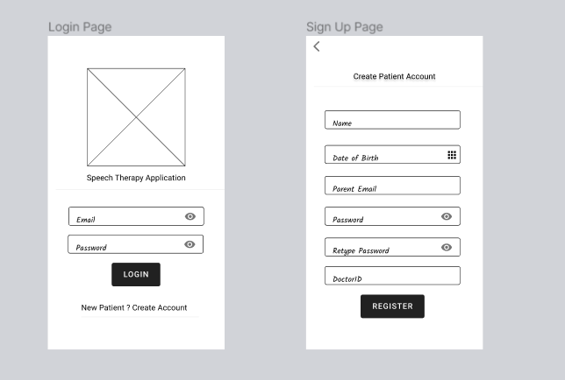

Figure 5.1 Login/Sign Up Pages

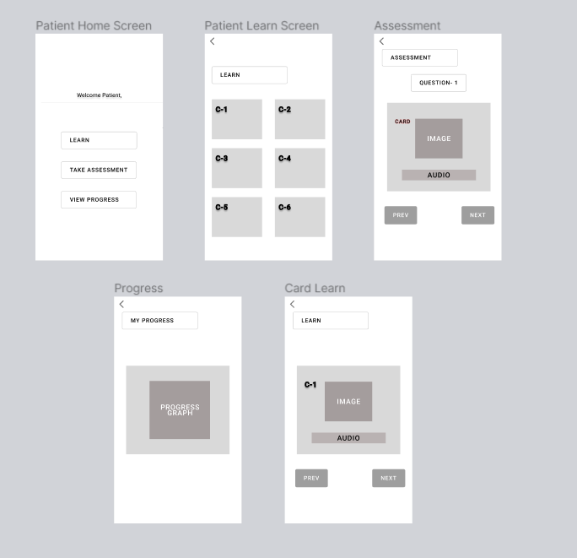

Figure 5.2 Patient Screens

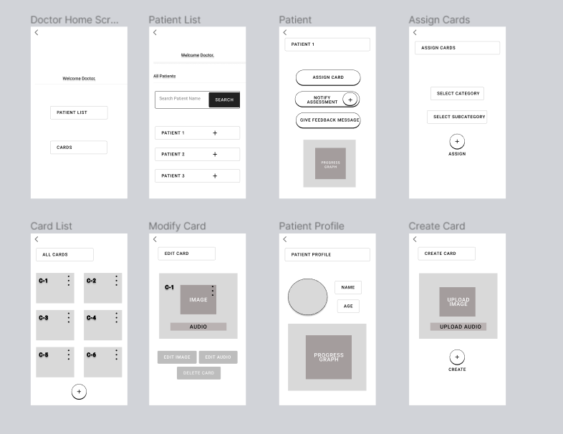

Figure 5.3 Doctor Screens

## User Interfaces

### Doctor Screens:

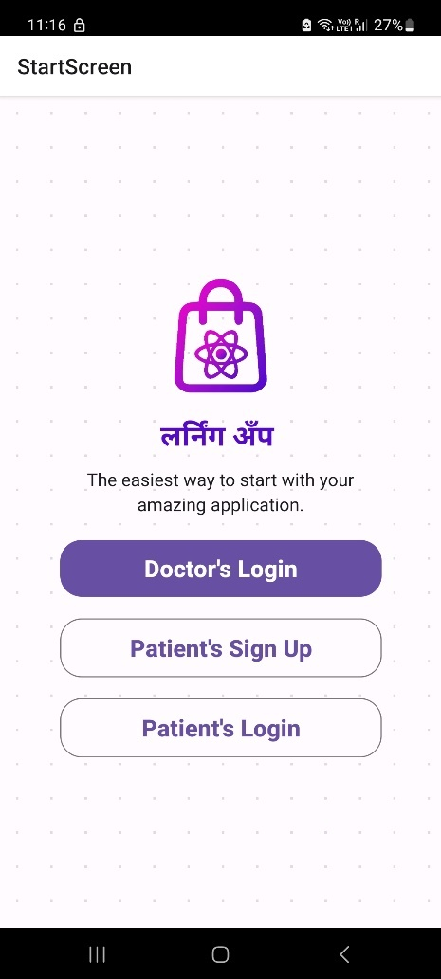 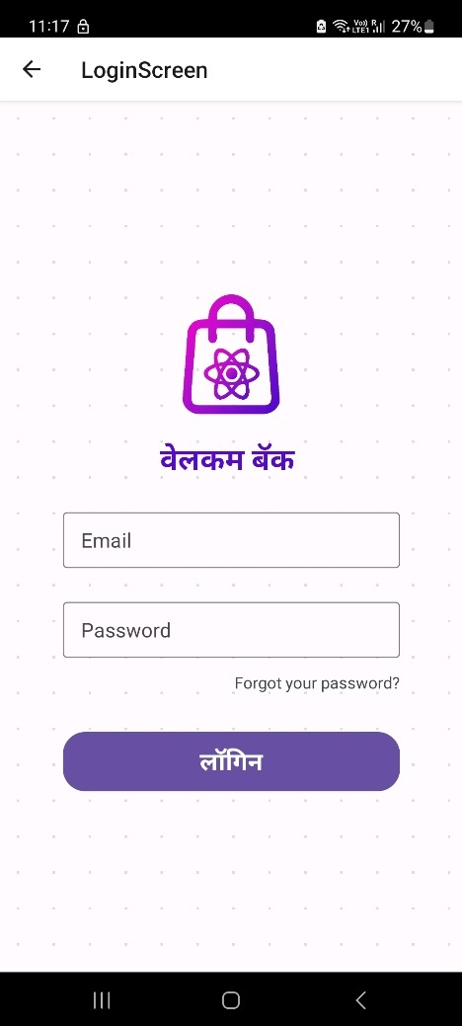

Figure 5.2.1.1 Login Screen

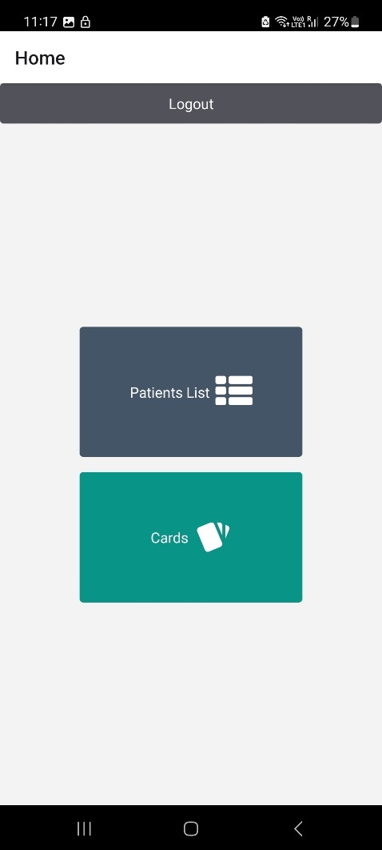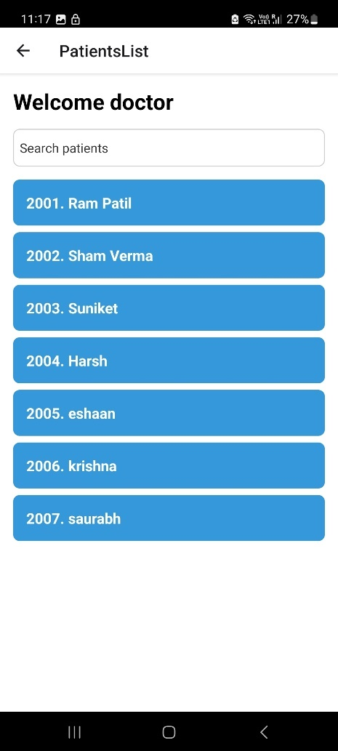

Figure 5.2.1.2 Dashboard and Patient List

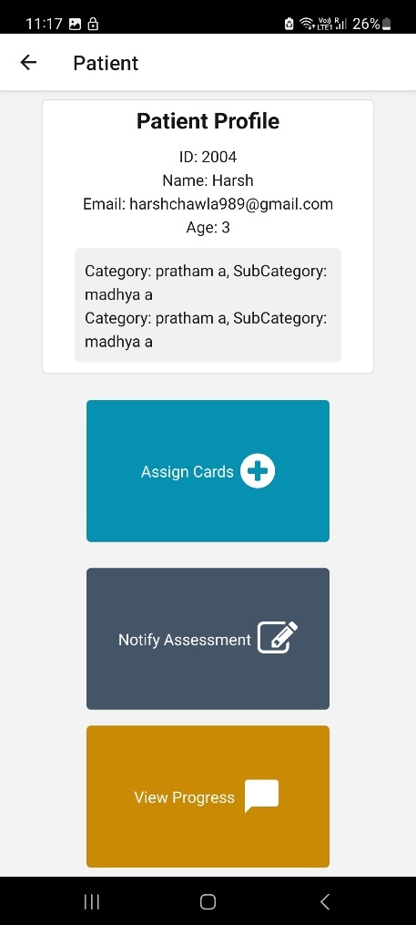 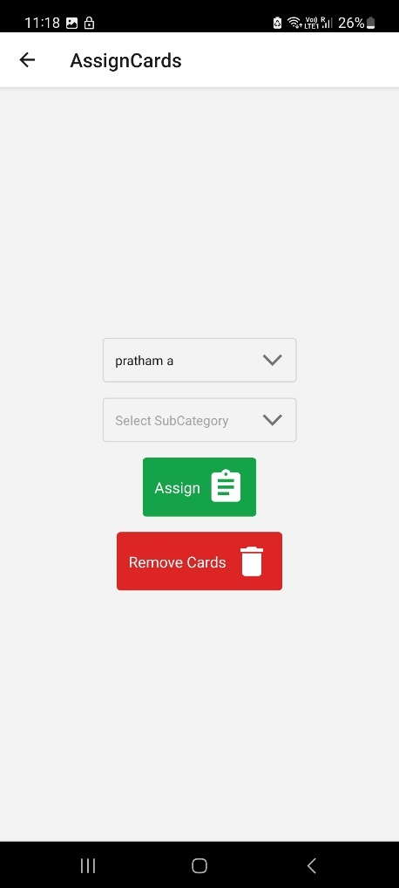

Figure 5.2.1.3 Patient Profile and Assign Cards

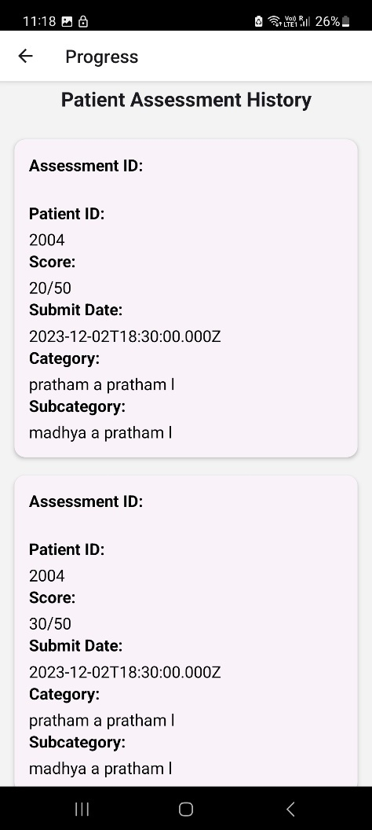 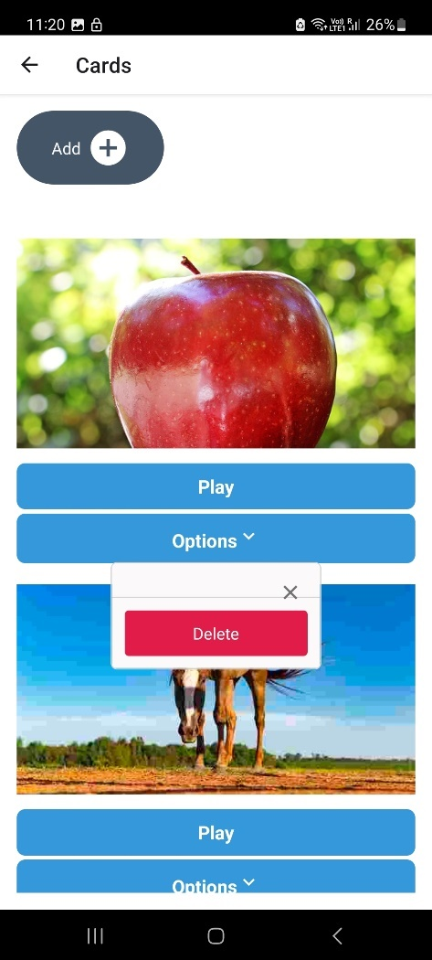

Figure 5.2.1.4 Progress of Patient

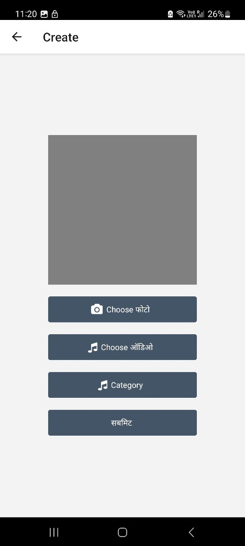

Figure 5.2.1.5 Create Card

### Patient Screens:

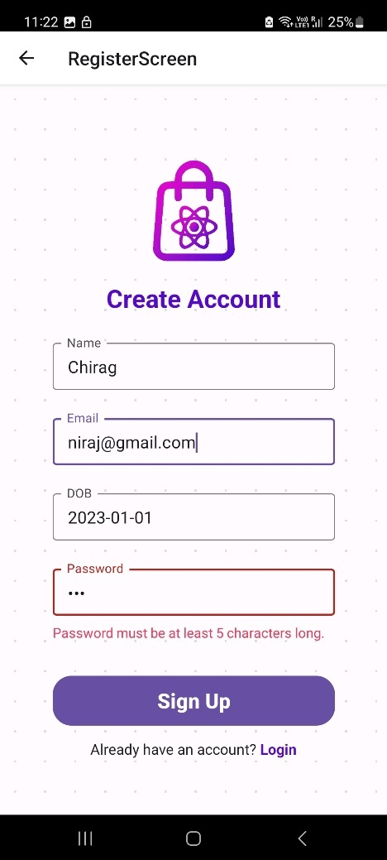 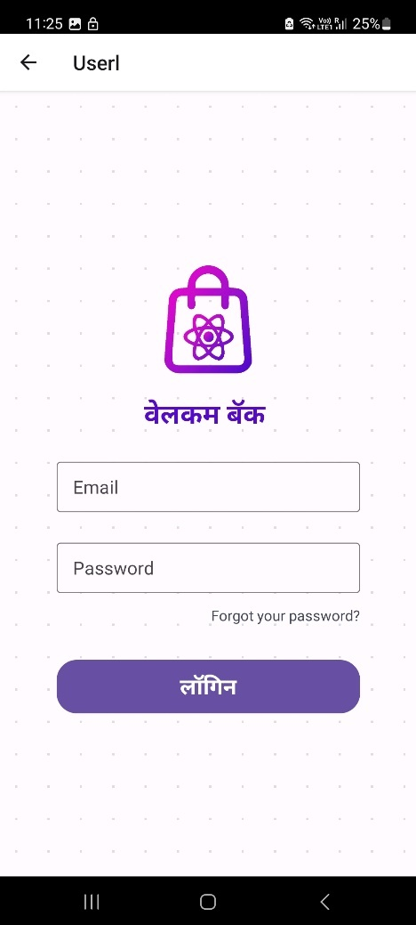

Figure 5.2.2.1 Patient Login/ Register window

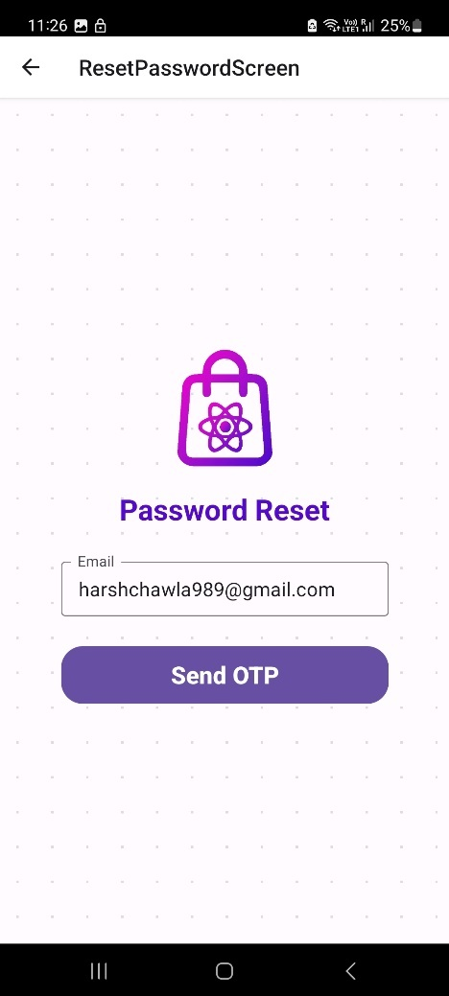 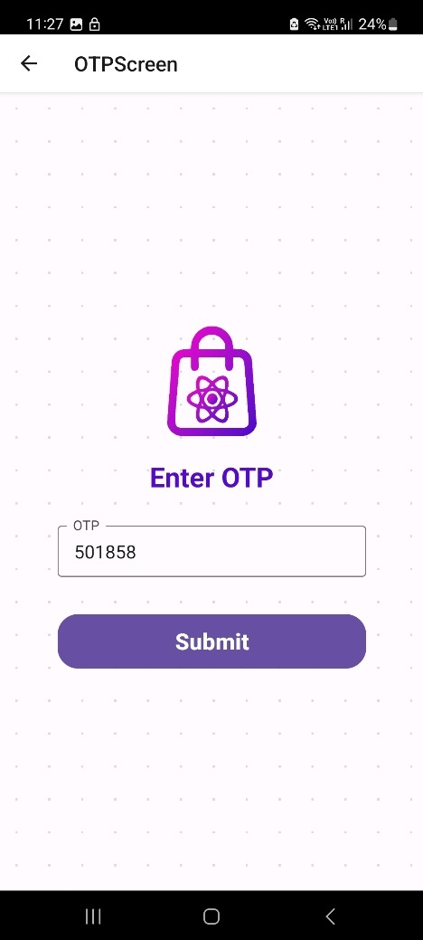

Figure 5.2.2.2 Forget Password

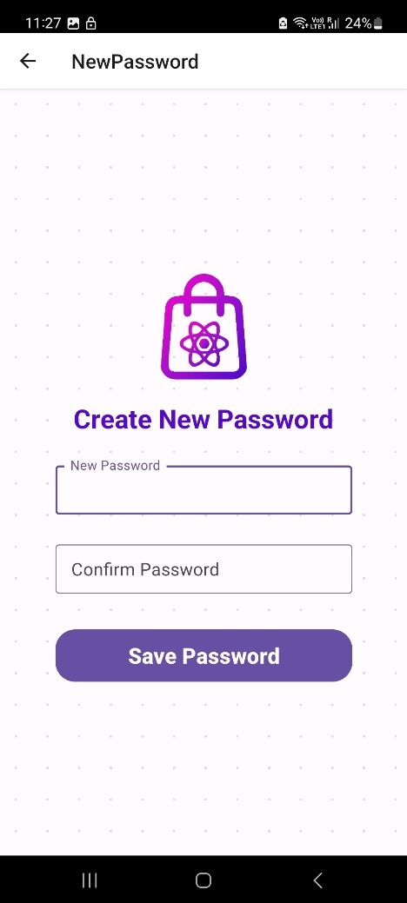

Figure 5.2.2.3 Reset Password

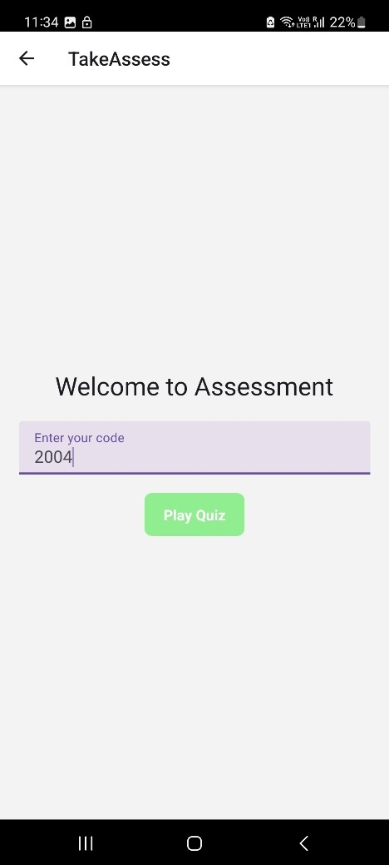 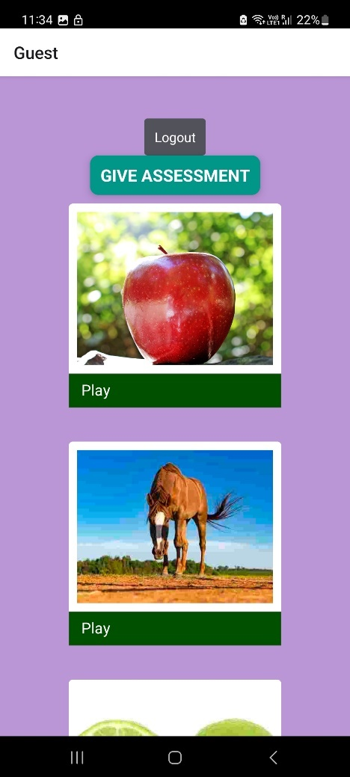

Figure 5.2.2.4 Assessment

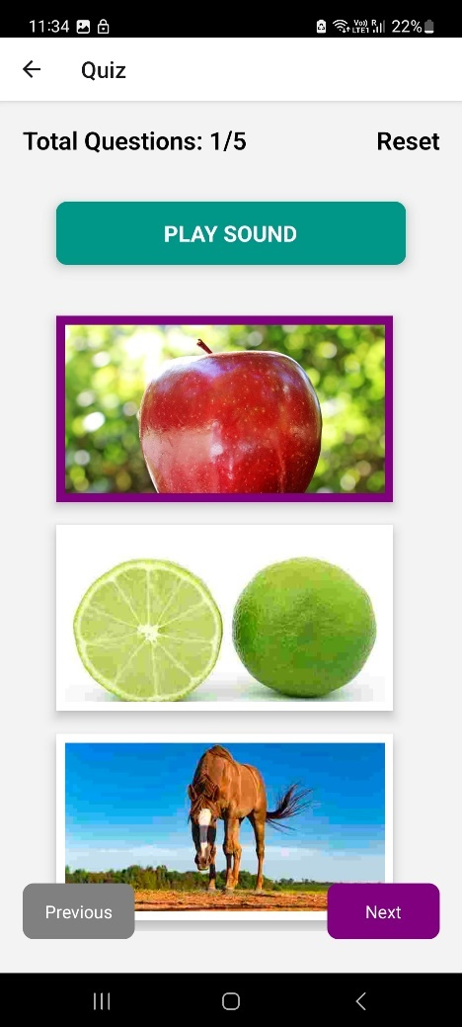 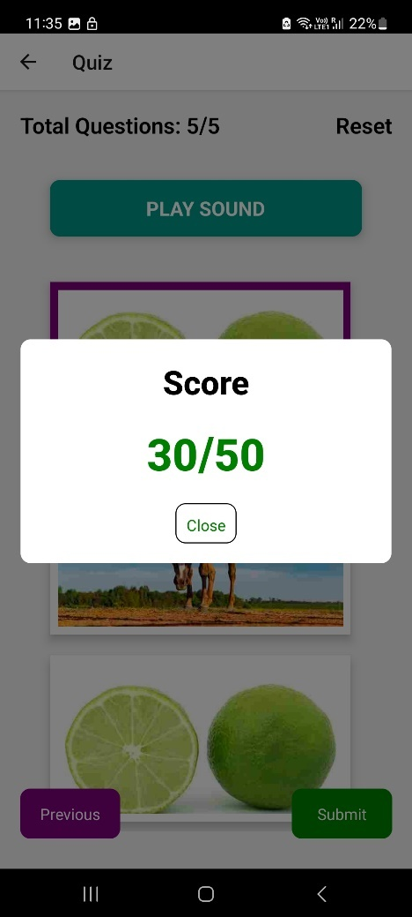

Figure 5.2.2.5 Give Assessment and get score

## Hardware Interfaces

This app is supported on all android as well as ios devices. The requirements are speaker and display to the device. This app has various functions as mentioned below:

Supported Devices: The application is designed to run on both Android and iOS platforms, indicating compatibility with a range of smartphones and tablets.

Device Specifications: For optimal performance, users are recommended to have a smartphone or tablet. The application is optimized for devices with screen sizes ranging from 4.7 inches to 10 inches.

Microphone: The application requires permission to access the device's microphone for audio recording purposes. This is likely used for speech therapy exercises and assessments.

Android and iOS Versions: For optimal performance, users are recommended to have Android version 4.1 or higher and iOS version 8.0 or higher installed on their devices.

These hardware interfaces and requirements ensure that the application functions properly on a variety of devices and that it can access the necessary hardware components like the microphone for its features, particularly those related to speech therapy exercises and assessments.

## Software Interfaces

Operating System Compatibility: The application is compatible with both Android and iOS platforms, indicating that it interacts with the operating systems of these mobile platforms.

Database Management System (DBMS): The software interfaces with a MySQL database. This means it communicates with and utilizes a MySQL DBMS for data storage and retrieval.

Frontend Technology: The frontend of the application is built using React Native, which is a popular cross-platform mobile app development framework. React Native is used for creating the user interface and user interactions.

Backend Technology: The backend of the application is built using Node.js and Express.js. These technologies likely handle server-side logic, authentication, and interactions with the database.

Cloud Technology: The application integrates with the Cloudinary platform for efficient management of media files, including images and audio pronunciations associated with therapy cards.

Analysis Tool: Power BI is integrated into the application for data analysis and reporting purposes. Power BI is used to generate visual reports on user progress and therapy effectiveness.

Development Platform: Visual Studio Code is mentioned as the development platform for building the application, indicating that it is used by developers to write and test the application code.

These software interfaces define how the Speech Therapy Assessment Application interacts with various software components, databases, development frameworks, and analysis tools to deliver its functionalities.

# SYSTEM FEATURES

User Registration: Users can create accounts or sign in as guests, while administrators can log in using their credentials. User authentication ensures data privacy and security.

Content Management: Administrators can add, modify, or delete speech therapy materials and assessment questions in Marathi. They can create new categories for therapy content and customize the learning experience.

User Management: Administrators can manage user accounts, including creating and managing therapist accounts.

Password Management: Admins can change their login passwords for security purposes.

Category Selection: Users (children with ASD and their parents/caregivers) can select specific categories of therapy content, such as Marathi alphabets, words, or sentences.

Interactive Exercises: Users can engage in speech therapy exercises designed to improve pronunciation and communication skills. Exercises may include image-based associations and pronunciation practices.

Audio Pronunciations: The application provides audio pronunciations for therapy content, helping users learn correct pronunciation.

Assessments: Users can undergo assessments to evaluate their progress in speech and language development.

Session Time Recording: The application records the time spent on each session to monitor user engagement.

SQL Database: The system uses an SQL database to securely store user data, therapy content, assessment results, and session history.

Media Management: Cloudinary is integrated for efficient management of media files, including images and audio pronunciations associated with therapy cards.

Power BI Integration: The application integrates with Power BI for data analysis and reporting. It generates visual reports on user progress and therapy effectiveness.

Android and iOS Support: The application is compatible with both Android and iOS platforms, ensuring accessibility for a wide range of devices.

Marathi Language: The application primarily supports the Marathi language, including therapy content, audio pronunciations, and the user interface.

# OTHER NONFUNCTIONAL REQUIREMENTS

## Performance Requirements

The performance requirements for this app are that the user should be familiar with the basic functionalities of mobile phone and should be able to use them. The admin should place all the images and audio for a card very precisely because this may lead to learning the wrong pronunciation. For user he/she should wait for some milliseconds to listen the pronunciation. Admin should remember the password to login and make changes into the data of app. User can select sign up or sign in (one time) and proceed further for learning.

## Security Requirements

Admin should maintain a strong password so that no other person can make changes to the app data. The child user should be supervised by the parent user. The database is secured with the default SQLite security feature.

## Software Quality Attributes

The primary objective is to create a good software which is judged using the following guidelines:

Consistency - All system code should be consistent.

Test cases - All functionalities are tested properly.

Reliability -The protocol communication should be reliable.

Availability - The product should be available on internet as well as on app stores.

Maintainability- The system should be maintained and updated regularly. The addition of new features should be easy and convenient.

## Business Rules

The business rules for the software are as follows:

The admin has the right to fix the spellings and images and to set or update the pronunciation as and when required.

The user should download the application in his/her device.

Admin should keep adding new words/sentences as well as categories.

Admin should maintain a high security password.

# PROJECT ANALYSIS AND DESIGN

## Use case Diagram

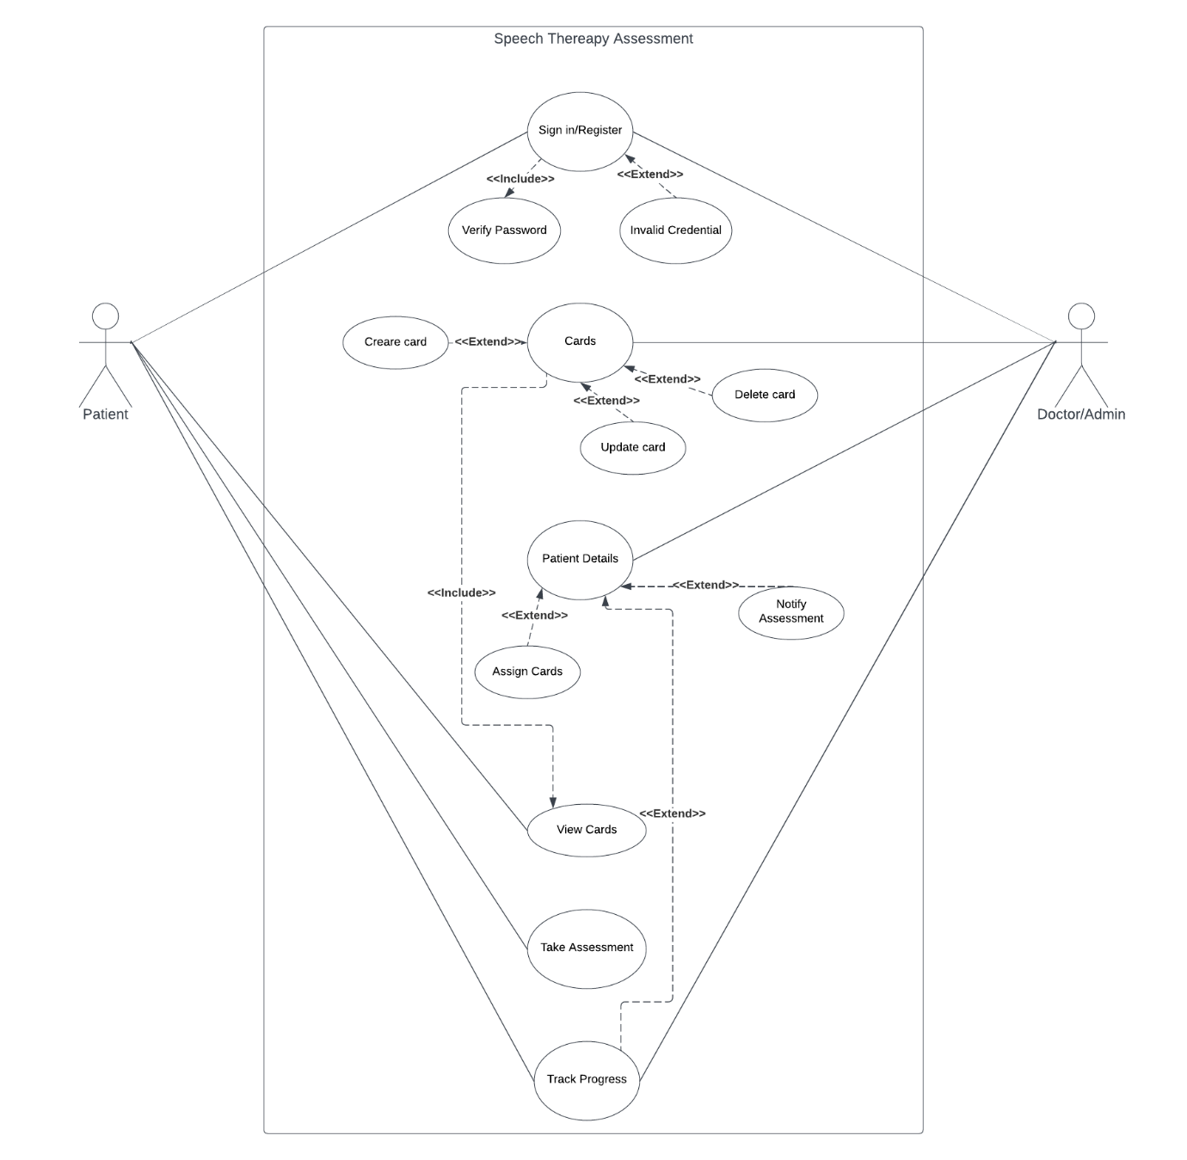

Figure 8.1 Use Case Diagram

## Admin Flow Diagram

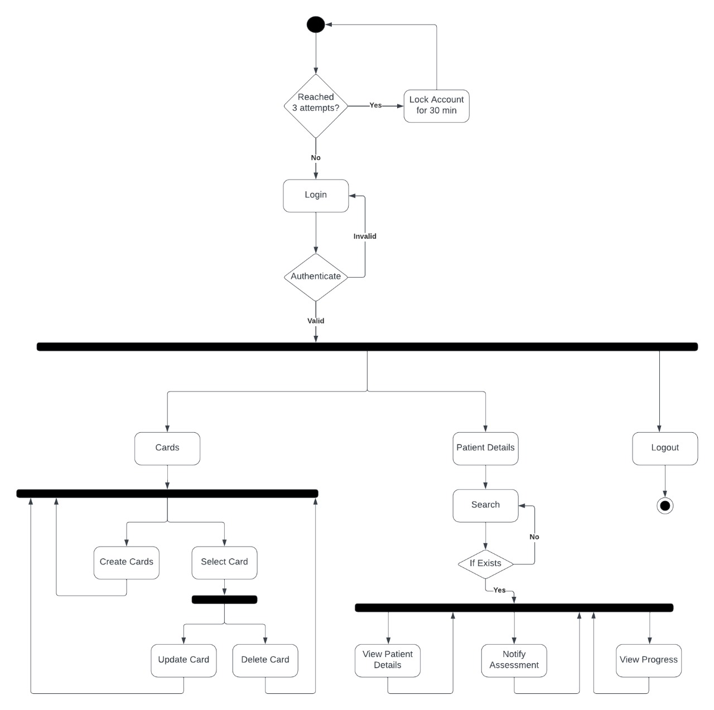

Figure 8.2 Admin Flow Diagram

## User Flow Diagram

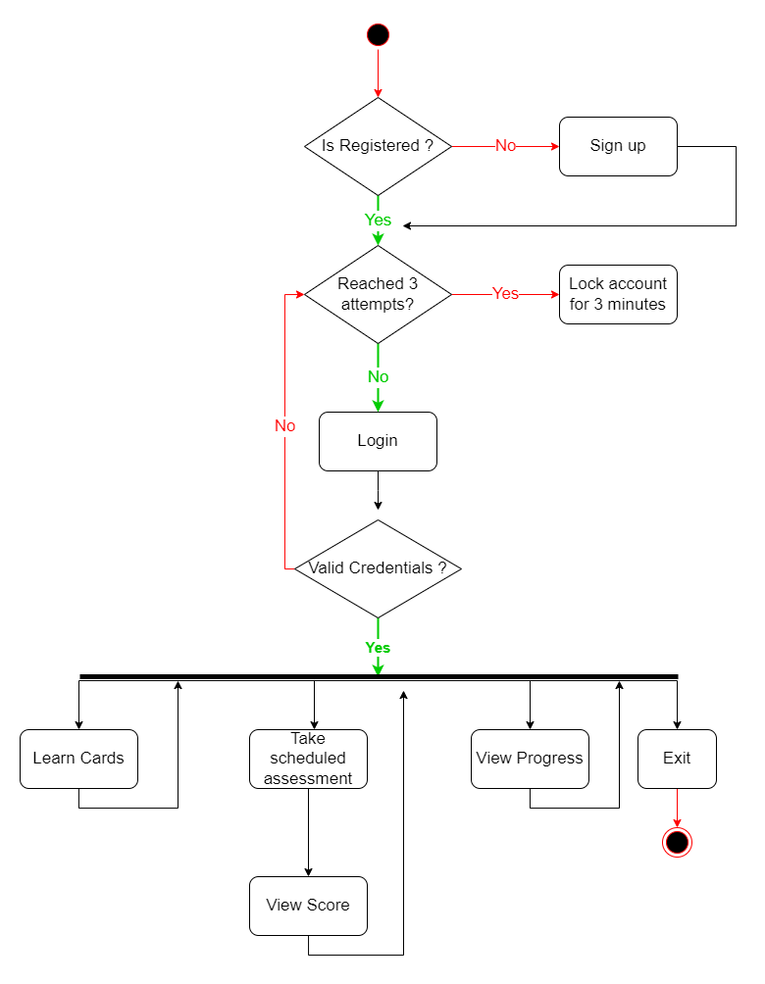

Figure 8.3 User Flow Diagram

## Sequence Diagram

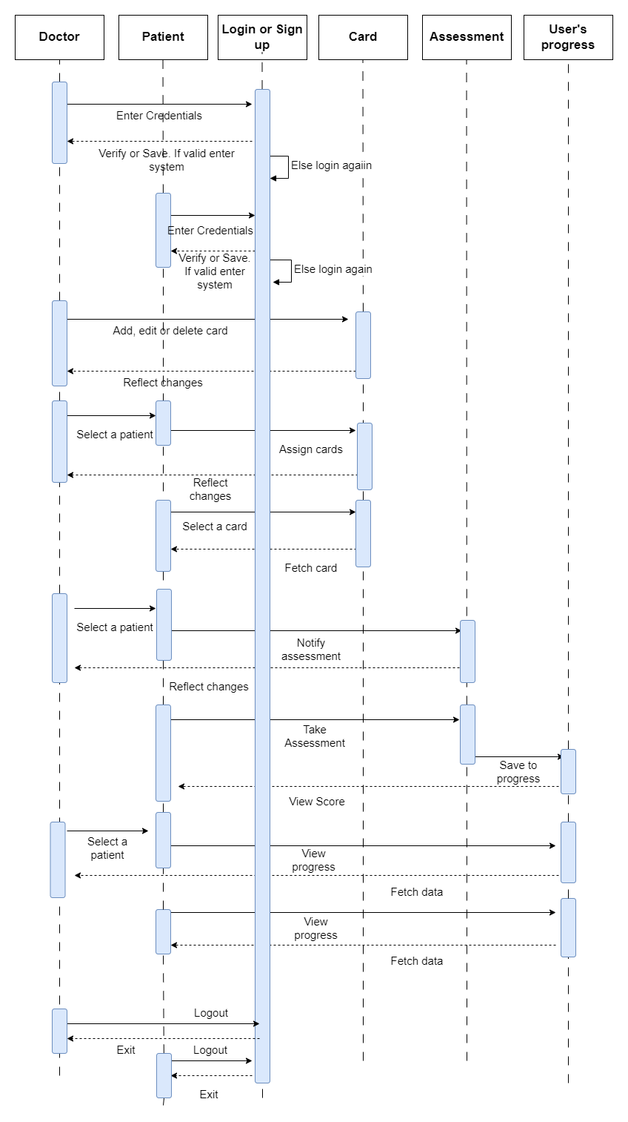

Figure 8.4 Sequence Diagram

## Class Diagram

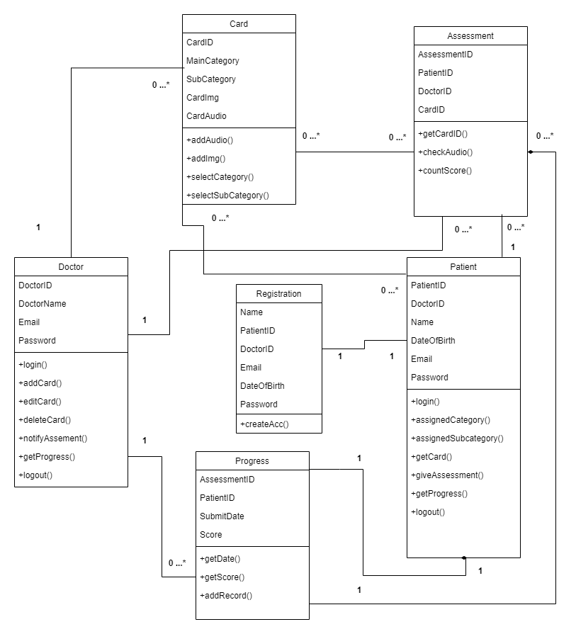

Figure 8.5 Class Diagram

## Component Diagram

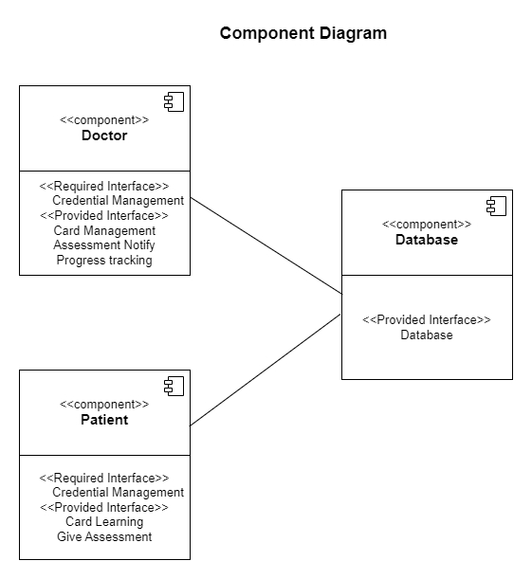

Figure 8.6 Component Diagram

## Deployment Diagram

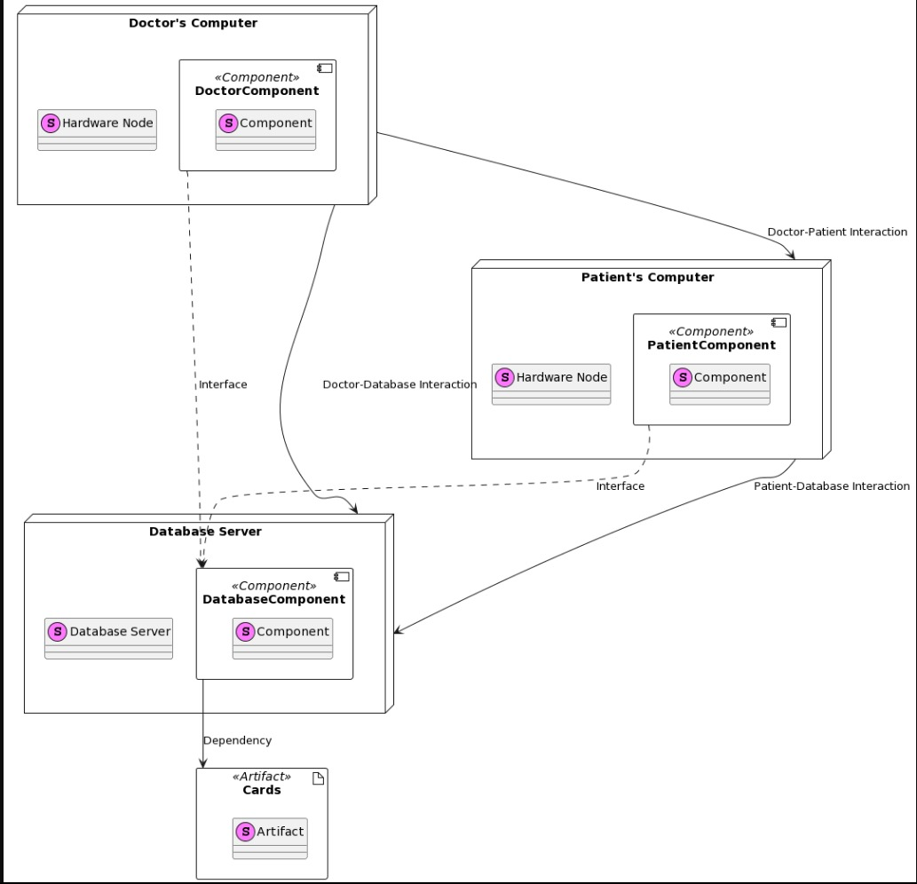

Figure 8.7 Deployment Diagram

## ER Diagram:

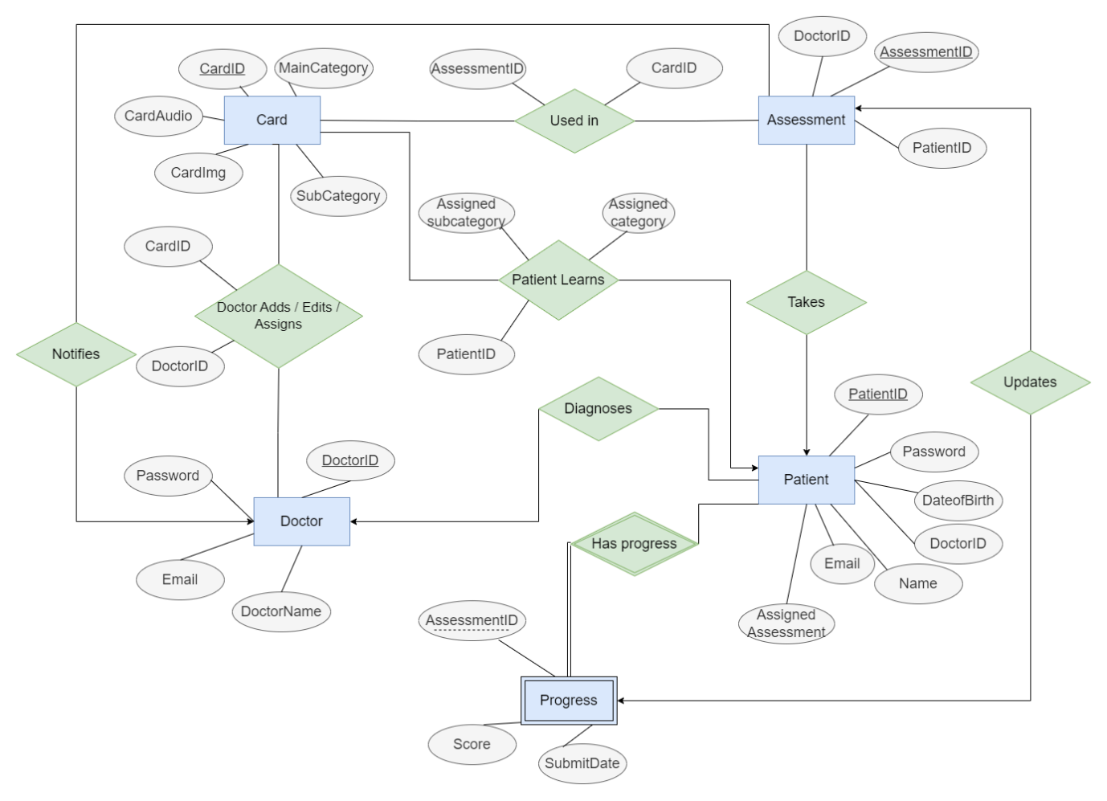

Figure 8.8 ER Diagram

# TEST CASES

|  |  |  |  |  |  |  |
| --- | --- | --- | --- | --- | --- | --- |
| Test Case No. | Test Case Name | Prerequisites | Action | Expected Result | Actual Result | Status |
| 1 | Login | Username and  password  should  be  entered | Click on  login  button | Successful login  for  correct  username  and  password | Successful  login | Pass |
| 2 | Login | Username and password  Should be  entered | Click on  login  button | Unsuccessful  login  for wrong  username  and  password | Unsuccessful  login | Pass |
| 3 | Patients List | Doctor should  be logged in. | Click on “Patients button” | Successfully see  list of all patients. | List of patients. | Pass |
| 4 | Patient  Profile and Functions. | Doctor should  be logged in. | Click on particular patient button. | Successfully  view patient’s profile and other function’s  buttons. | View patient’s profile and  buttons of other functions. | Pass |
| 5 | Assign  Cards | Select details. (category, subcategory) | Click on “Assign” button | Data will be uploaded to the database and app will reflect the changes. | Successful assignment of respective cards  to that patient. | Pass |
| 6 | Remove  Cards | Select details. (category, subcategory) | Click on “Remove” button | Data will be removed from  the database | Successful  removal of respective cards  for that patient. | Pass |
| 7 | Notify assessment | Doctor should be logged in.  Select the patient | Click on  “Notify Assessment” Button | Particular patient will be assigned  an assessment based on  assigned cards. | Successful assignment of  the assessment. | Pass |
| 8 | View  Progress | Doctor should be logged in.  Select the patient | Click on “Progress” Button | Successfully  view progress of that patient containing  details of  previous assessments. | Successfully  fetch patient’s progress. | Pass |
| 9 | Cards | Doctor should be logged in. | Click on “Cards”  Button | Successfully  view all cards which are fully functional with respective image, and audio. | Successfully  view cards and  able to see image and play audio. | Pass |
| 10 | Add card | Doctor should be logged in.  Add image, audio, category and subcategory. | Click on  “Add Card” Button | Successfully add card to the  database and  reflect changes in the app. | Successful  addition of card  to the app. | Pass |
| 11 | Add card credentials | Add image,  audio, category and subcategory. (improper) | Click on  “Add Card” Button | Unsuccessful addition of card  to the database  and show alert. | Show alert and failed action. | Pass |
| 12 | Delete card | Doctor should be logged in.  Select a card | Click on  “Delete card” Button | Successfully  delete card to the database and  reflect changes in the app. | Successful  addition of card  to the app | Pass |
| 13 | Logout | Doctor should be logged in. | Click on  “Log out” Button. | Successfully log doctor out and direct to the start screen. | Successful  logout. | Pass |
| 14 | Registration  For patient | No  prerequisites | Click on  “Sign Up”  Button. | Successfully  Create account  For patient. | Successful  Account creation. | Pass |
| 15 | Play Cards | Patient should  Be logged in. | Click on  “play”  Button. | Voice should be  generated for  given card. | Successful  Voice generation. | Pass |
| 16 | Give assessment | Patient should  Be logged in. | Click on  “Give assessment”  Button. | User should be  Forwarded to  Authentication  Page. | Successfully  Forwarded to  New page | Pass |
| 17 | Authentication | Patient should  Be logged in. | Input the  Unique code  Given by  Doctor. | Successful authentication. | Successful navigation to  Assessment page. | Pass |
| 18 | Authentication | Patient should  Be logged in. | Input the  Unique code  Given by  Doctor. | Unsuccessful authentication. | Unsuccessful navigation to  Assessment page. | Pass |
| 19 | Assessment | Patient should  Be authenticated. | Mark the correct option. | Successfully  Selected correct  Option. | Successfully  Saved correct  option | Pass |
| 20 | Display result | Patient should  Be logged in and  authenticated. | Click on  “Submit”  Button. | It should show correct option. | Successfully  display correct option. | Pass |

Table 1 Test Cases

# CONCLUSION

## Main Findings:

In summary, the research affirms the positive impact of our client-server mobile application on the diagnostic and therapeutic journey for individuals with autism. The app's innovative features, technological foundations, and user-centric design contribute to a comprehensive solution for healthcare professionals and patients alike.

## Significance of the Research:

This research underscores the significance of leveraging technology to enhance personalized care in the field of autism 6 interventions. The positive outcomes reaffirm the potential of collaborative and accessible tools in improving patient outcomes and caregiver engagement.

## Areas for Future Research:

Future research endeavours may explore further enhancements to the app, including the integration of additional therapeutic activities, expanded multimedia options, and adaptive learning algorithms. Additionally, longitudinal studies could provide insights into the long-term impact of the app on individuals with autism. This research contributes to the ongoing discourse on technology-assisted interventions for autism, emphasizing the importance of collaboration, personalization, and innovation in shaping the future of healthcare practices for individuals with ASD.

# PROJECT PLAN 2.0

In Project Plan 2.0, we are taking our commitment to addressing the needs of individuals with autism disorder to the next level. Recognizing the severe lack of accessible therapy services in rural and underserved regions, we are determined to bridge this gap by introducing a free tier service. Our mission is to extend the benefits of speech therapy to those who often face geographical and financial barriers to care. By offering this free service in rural parts where autism treatment options are virtually non-existent, we aim to make a positive impact on the lives of individuals and families affected by autism. This initiative reflects our dedication to inclusivity and our vision of a world where every individual, regardless of their location or socioeconomic status, can receive the support they need to thrive.

# REFERENCES

1. Autism Spectrum Disorders By Catherine Lord ‡ Edwin H. Cook, Bennett L. Leventhal, and David G. Amaral
2. Smartphone Apps for Autism Spectrum Disorder—Understanding the Evidence Jung Won Kim1 & Thuc-Quyen Nguyen2 & Shih Yee-Marie Tan Gipson3 & Ah Lahm Shin1 & John Torous4
3. Puzzle Walk: A Gamified Mobile App to Increase Physical Activity in Adults with Autism Spectrum Disorder
4. Evaluation of Tablet Apps to Encourage Social Interaction in Children with Autism Spectrum Disorders Juan Pablo Hourcade, Stacy R. Williams, Ellen A. Miller, Kelsey E. Huebner, Lucas J. Liang
5. Development of a Mobile App to Improve Numeracy Skills of Children With Autism Spectrum Disorder: Participatory Design and Usability Study Theoneste Ntalindwa 1 , MSc; Mathias Nduwingoma1 , PhD; Evariste Karangwa 2 , PhD; Tanjir Rashid Soron3 , MD, MPH, MSc; Alphonse Uworwabayeho1 , PhD; Annette Uwineza4 , MD, PhD
6. Applied Behavior Analysis: Its Application in the Treatment of Autism and Related Disorders in Young ChildrenSandra L. Harris, PhD Professor of Clinical Psychology Graduate School of Applied and Professional Psychology Lara Delmolino, PhD Research Assistant Professor Douglass Developmental Disabilities Center Rutgers, The State University of New Jersey New Brunswick, New Jersey
7. Children with Autism Spectrum Disorder and Patterns of Participation in Daily Physical and Play Activities Amir Hossein Memari,1 Nekoo Panahi,1 Elaheh Ranjbar,1 Pouria Moshayedi,2 Masih Shafiei,1 Ramin Kordi,1 and Vahid Ziaee3
8. Mise au point/ in-depth review autism in review simone khalifeh1,2,3, walid yassin2,3, silva kourtian2,3,4, rose-mary boustany1,2,3
9. Features of Mobile Apps for People with Autism in a Post COVID-19 Scenario: Current Status and Recommendations for Apps Using AI Ikram Ur Rehman 1 , Drishty Sobnath 2 , Moustafa M. Nasralla 3 , Maria Winnett 1 , Aamir Anwar 1 , Waqar Asif 1 and Hafiz Husnain Raza Sherazi 1,
10. Assisting Children with Autism Spectrum Disorder with Educational Mobile Apps to Acquire Language and Communication Skills: A Review Azham Hussain () Universiti Utara Malaysia, Sintok, Malaysia hussazham@yandex.com Emmanuel O.C. Mkpojiogu Universiti Utara Malaysia, Sintok, Malaysia Veritas University, Abuja, Nigeria Pauline Chiamaka Okoroafor Veritas University, Abuja, Nigeria
11. Increasing communicative interactions of young children with autism using a voice output communication aid and naturalistic teaching maureen m. Schepis family, infant, and preschool program and western carolina center dennis h. Reid carolina behavior analysis and support center and louisiana state university medical center michael m. Behrmann george mason university and kelly a. Sutton western carolina center foundation
12. Interventions for Children with Autism Spectrum Disorders in Inclusive School Settings Lynn Koegel, Rosy Matos-Fredeen, Russell Lang, and Robert Koegel, University of California, Santa Barbar
13. Interactive Technologies for Autistic Children: A Review Sofiane Boucenna, Antonio Narzisi, Elodie Tilmont, Filippo Muratori, Giovanni Pioggia, David Cohen & Mohamed Chetouani
14. Autism Children’s App based intervention
15. Applications for Children with Autism in Preschool and Primary Education Maria Xanthopoulou (*), Georgia Kokkalia, Athanasios Drigas National Center for Scientific Research-Demokritos, Attica, Greece maxanthopoulou@yahoo.com
16. Autism Children’s App using PECS Nareena Soomro1, * and Safeeullah Soomro